Thread Chair Instructions
These supplement the content in https://systemdynamics.org/submission-instructions/
Contents
Overview and Key Dates 1
1. Reading Assigned Submissions 2
2. Adding or Editing Keywords 2
3. Rating Submissions 2
4. Rating Peer Reviews 2
5. Writing Reviews 3
Interacting with the Program Chairs 3
Conflicts of Interest 3
Appendix 4
How to submit a test paper 4
Submission Placement Process 4
Rejection 5
Work in Progress (WIP) Submissions 5
Practitioner Application Submissions 6
Research Paper Submissions 6
Reading Supporting Materials 6
Conference Proceedings 6
Past Submissions by Thread 7

Overview and Key Dates
Thread chairs are an integral part of the Conference Program Committee. They are responsible for:
- Reading all assigned submissions (research papers, practitioner applications, and works in progress).
- Adding or editing the keywords for each assigned submission.
- Rating the quality of each submission on a scale of 1-10, where 10 is highest quality. (Rejections are based on plagiarism or inapplicability only.)
- Rating the quality of each peer review for assigned submissions.
- Providing a written review for any submissions without a constructive review.
Key dates are below:
- January 16, 2024: Submission window opens.
- March 19, 2024: Submission window closes. You can review submissions before this date, as they are assigned.
- April 2, 2024: Final peer reviews are due. All information coming from this process will be available.
- April 9, 2024: Thread Chair assessments and peer review ratings are due.
- April 30, 2024: Thread Chair reviews are due.
To ensure that the Conference Program can be completed in a timely manner, the final deadline to submit the Thread Chair Reviews must absolutely be met. Please mark your calendar now.
Remember, there is no need to wait until all papers have been submitted to begin your evaluation. You may start working through the individual papers in your thread at any time after submissions open. If you log on periodically and check for new papers and submitted reviews, this will ease your workload when it comes to the end of the process.

1. Reading Assigned Submissions
In the new Thread Chair workflow, you will be presented with a list of submissions to read and rate, both from within your primary thread and from up to three other threads. You will be able to access these submissions by logging in to the web portal.

2. Adding or Editing Keywords
Important to the new Thread Chair workflow is the assignment of keywords to each submission. As a Thread Chair, it is your job to ensure that the keywords supplied by the author are relevant, and to add any of your own to help with the algorithm for session creation. Our preference is that where possible, you reuse keywords rather than creating derivatives of existing keywords.

3. Rating Submissions
Rating of submissions must be based on quality of content and the fit of that content with a System Dynamics conference. Apart from these general standards which should always be applied, we ask you to remember that the criteria for what makes a good conference presentation, though equally high, may be different from those for journal articles.
Peer reviews oftentimes do not help to identify the highest quality work. It is your job as a Thread Chair to read each assigned submission and give it a quality score based on your understanding of the underlying work.
For each submission assigned, you will be required to provide a numeric rating from 1-10, where 10 is the highest quality. If you believe a submission should be rejected due to plagiarism or lack of relevance, do not enter a quality score, then select the option to recommend rejection. You will be prompted to explain why.
Please remember that there are three different kinds of submissions:
- Research Papers
- Practitioner Applications
- Work in Progress (WIP) Descriptions
Research Papers and Practitioner Applications are full submissions, which may be placed by the Program Chairs into any session type. When giving them a quality score, be sure to be even-handed across the two submission types. Because Practitioner Applications are submitted as a set of slides, they look very different than traditional Research Papers. However, we need to be mindful that they can and often do represent the same level of quality. Please don’t let the format of the presented information impact your rating of the quality of the underlying work being presented.
WIP Descriptions (extended abstracts) can only be placed by the Program Chairs into WIP or Feedback sessions. Please be sure to be consistent in your rating of WIP Descriptions as their own category. It is OK if you use a different heuristic for coming up with a quality score for these.

4. Rating Peer Reviews

Thread Chairs should rate each review of the papers that have been assigned to them. The process for rating a review is as follows:
1. Click on the word “Rate”
2. Complete this sentence “This review is:” by pressing the appropriate radio button
3. Press “Submit”
Please “rate the reviewer” based on the current review. Your rating of the review is confidential, i.e., the reviewer does not have access to their rating, and all review ratings are aggregated per reviewer. Reviewer ratings appear in parentheses next to the reviewer’s name. An unrated reviewer will have NO PARENTHESES next to their name. This is a subtle but important difference from a reviewer with empty parentheses ( ) after their name, meaning that their reviews have been rated as Worthless (no stars).
( ) Worthless
(*) Poor
(**) Fair
(***) Good
(****) Excellent
(*****) Outstanding
The review process is open to a variety of people and not all have the aptitude or ability to write helpful and concise reviews. Some reviews are just bad. The benign ones simply do not say very much. Generally, the written comments are the best indicator that the reviewer has done the job of reading and communicated their assessment clearly. There may, however, be reviews that are just plain destructive. This may be because the reviewer has written something hurtful or stated things that simply are not true. If you feel that the authors will not benefit from seeing the review, you have the option to block it. This should not be done lightly, and you should add a note to the Program Chairs if you decide to do this.
To block a review, click on the Rate/Block link. A window will pop up allowing you to rate the review (presumably the Worthless category applies, with no stars) and there will be a checkbox to block it. Blocked reviews will not appear to authors, and the blocked review will no longer appear for Thread Chairs. Only the Program Chairs will be able to see blocked reviews.
Reviewers will not see their own ratings, and they will not know if their review has been blocked. You may provide constructive feedback to a reviewer through the Web Portal.

5. Writing Reviews
Write a review for each assigned submission that is lacking a constructive written review.

Interacting with the Program Chairs
The Program Chairs will use your evaluations and written reviews as a guide when assembling the conference program. Revisions will then be made to fit the time and space resources available.
If you have recommendations for plenary presentations, please make these as soon as possible and do not wait until you have finished everything else.
Let the Program Chairs (progchair@systemdynamics.org) know if you have any program questions or concerns. Please contact Bob Eberlein (webmaster@systemdynamics.org) with questions about using any part of the Web Portal.
Thank you for your invaluable effort.

Conflicts of Interest
(from Program Guidelines)
A Thread Chair may submit a paper for presentation. That Thread Chair will not evaluate their own paper and should not view the program committee page for the paper.

Appendix

How to submit a test paper
Here are some abbreviated instructions to submit a test paper.
TIP: It helps to have test pdf/.ppt/.pptx files ready to upload (less than 2 megabytes) in advance. Note the correct number of pages. (This can be a blank document.)
Log into System Dynamics website https://systemdynamics.org/, then go to https://webportal.systemdynamics.org/
On the initial login, the first page that opens is “Welcome to the System Dynamics Web Portal.” Scroll down to click the button “>>> continue to set up review preferences >>>.”
On the “Review Preferences for XXX” page, you may want to set your maximum number to zero as a Thread Chair. Then proceed by clicking the button “Record Preferences …”
On the page “User Menu for You” please use the button “New Submission.” (By default, this will be set to a conference submission.) On the “Submission Type Selection,” choose one: Research Paper, Practitioner Application, or Work in Progress and proceed using the “Continue to Thread Selection” button. Note: Once you have selected a type it cannot be changed.
On the page “Thread Selection” pick a primary and alternate thread and use the button “Continue to Paper Information Entry.”
On the “Paper Information for Submission” page, provide all info:
Title (add TEST to the title)
200-word abstract
Link
Paper length
Author List, noting designated presenter and if all authors can update the submission.
Click the button “Submit.”
On the page “File Uploads for Submission” use the “Browse” button to find the test file and click the button “Upload File(s).”
In addition to your test papers, we have put in some other test papers to enable you to check that all is working correctly for you. Your “User Menu” page should contain the link “See Submitted Papers for Thread XXXX.” (If not, or the thread listed is not your thread, please alert the office at conference@systemdynamics.org, copy to webmaster@systemdynamics.org.) The papers you see may be primary papers in your thread, alternate papers, test papers, or incomplete submissions.

Submission Placement Process
All submissions are sent out for blind review. The reviews are expected to provide helpful commentary, but you should judge each paper on the submission itself. This means you need to read each submission, as well as the reviews, and form your own evaluation.
An overview of the disposition guidelines is provided in the diagram below. As indicated in the diagram and discussed below, any submission may be rejected for lack of relevance or plagiarism. Research Papers and Practitioner Applications will be considered for all session types. Work in Progress Descriptions will be considered for Work in Progress and Feedback Discussion sessions. The determination of Interactive sessions will occur by Program Chairs after authors have indicated whether they plan to attend in person or online. Online presenters in Interactive sessions will present in virtual poster sessions. In person presenters in Interactive sessions will choose between table talks and traditional poster sessions.
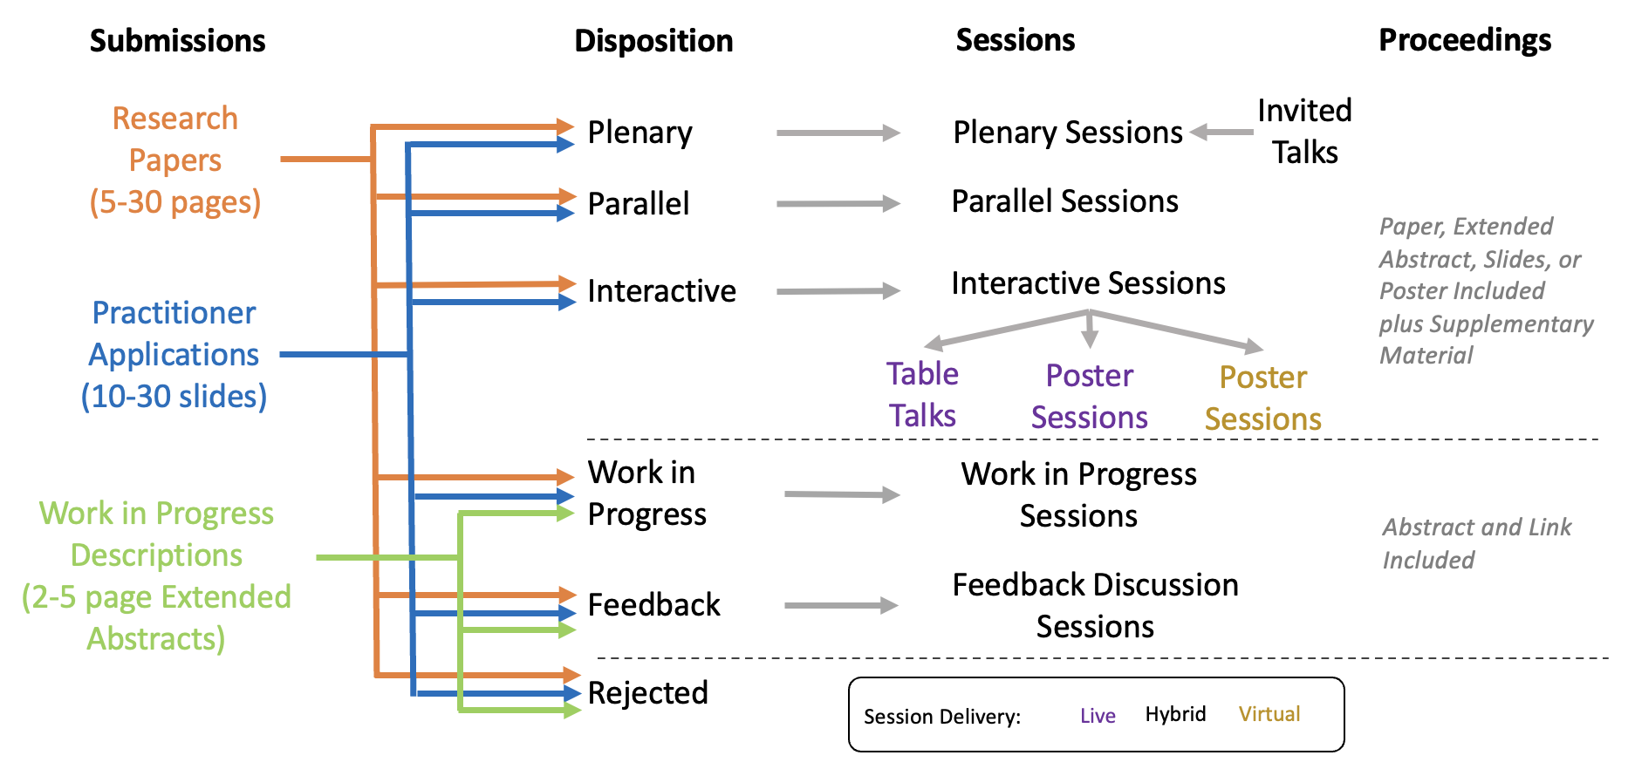

Figure 1: Submission Placement Process

Rejection
Paper submissions will be rejected that are nonsense (automatically generated text), written in a language other than English, not related to System Dynamics in any meaningful way (unless they would form part of a well-defined session that does relate), or are plagiarized or previously published. Work that has been submitted to, accepted for, or already presented at another conference, or accepted but not yet published in a journal, will be considered. Exceptions for submission of previously published work may be granted by the Program Chairs for presentations that reflect on past work in an original way.
All work that is not rejected for plagiarism or relevance will be placed in a session as discussed below for each submission type. If you see a paper that should be rejected for any of the above reasons, please let the Program Chairs know as soon as possible so that rejections can be handled as they are determined. The only exceptions to the relevance criterion for rejection may be for submissions that would fit well when combined with others in a Parallel, Interactive, or Work in Progress session, but that are not directly using System Dynamics or systems thinking. Thread Chairs should notify Program Chairs about any recommended exceptions to the rejection criteria as early as possible.

Work in Progress (WIP) Submissions
Work in Progress (WIP) submissions will only be considered for WIP or Feedback sessions. WIP descriptions are based on an extended abstract of 2-5 pages, with up to 2 pages of text plus the bibliography and any graphics included. The core criterion to consider is how well the content of the WIP is presented. First, and obviously, there must be a clear problem statement. In addition to the problem statement, there must be some evidence to indicate the author has actually started work in a meaningful direction. That could mean a clear reference mode and articulated dynamic hypothesis, or a model on which some experimentation or analysis has been done. Simply expressing some idea of how to do something or an experimental design description could suffice. A well-done literature search might also be enough.
Most WIP submissions will end up in WIP sessions. If it is not sufficient quality to express reasonable work in progress, it will be assigned to a Feedback session. Feedback sessions also have the advantage of not being dependent on the oral presentation skills of the author, since they are led by the session chair.

Practitioner Application Submissions
Practitioner applications consist of slides that would, approximately, be the slide set used in a Parallel or Plenary presentation. You will need to look through the slides, including any detail provided in the presenter notes, and decide whether the content warrants presentation. The same quality criteria used for Research Papers as described below should be applied, but there is likely to be somewhat less to go on. You can also give more weight to how interesting the presentation would be to listen to, as most of these submissions are unlikely to turn into papers. Practitioner application slides may be included in the Conference Proceedings for interactive (poster or table talk), parallel, or plenary presentations.
Practitioner application presentations that are not appropriate for Parallel sessions will be considered for an Interactive session if of sufficient quality, placed in a Work in Progress session if less developed, or assigned to Feedback sessions as appropriate. If the quality of the slides would not be suited for the Conference Proceedings, the practitioner applications should not be assigned to an Interactive session.

Research Paper Submissions
Only papers that are coherent, complete, and without obvious serious errors should be considered for Parallel sessions or recommended for Plenary presentation. Papers that are coherent, almost complete, and without glaring serious errors can be considered for interactive sessions as table talks or poster presentations. Poster sessions and table talks will be presented at separate times from other types of sessions. Authors of research papers presented as posters, table talks, parallel presentations, or plenary talks will have the opportunity to contribute a paper file (extended abstract, poster, or full paper) to the Conference Proceedings.
What is left after assigning papers to Parallel sessions and Interactive sessions (posters and table talks) will go into WIP sessions or Feedback discussion sessions. From the perspective of presentation slots, these two categories are the same, since up to 6 submissions may be discussed in each hour-long session. Parallel, WIP, and Feedback sessions are usually presented in the same time block. Both WIP and Feedback discussions are led by a session chair, but WIP authors present their own work. WIP sessions are designed for work that is partway along a path, and Feedback sessions are for work that seems lost or off the path altogether. Files from submissions presented in WIP and Feedback sessions are not included in the Conference Proceedings, but all authors are allowed to include a hyperlink to additional information.

Reading Supporting Materials
For all submission formats there may be Supporting Material that should also be reviewed. This information may contain model files or additional model documentation.

Conference Proceedings
All material presented at the conference will have the title, authors, abstract, and an optional hyperlink to a full paper or additional information included as part of the Conference Proceedings. Work accepted for Plenary, Parallel, and Poster sessions will optionally have an extended abstract (encouraged; see example), full paper, poster, or set of slides (for practitioner applications) included in the Conference Proceedings, and will include any supplementary material that has been submitted in the Conference Proceedings.
Because of the distinction in terms of what can be included in the Conference Proceedings, it is important for Thread Chairs to consider the quality criterion for an interactive session versus a work in progress presentation.
Information on what is included in the Conference Proceedings for each type of contribution is summarized below and available at https://systemdynamics.org/submission-instructions/#conference-record.

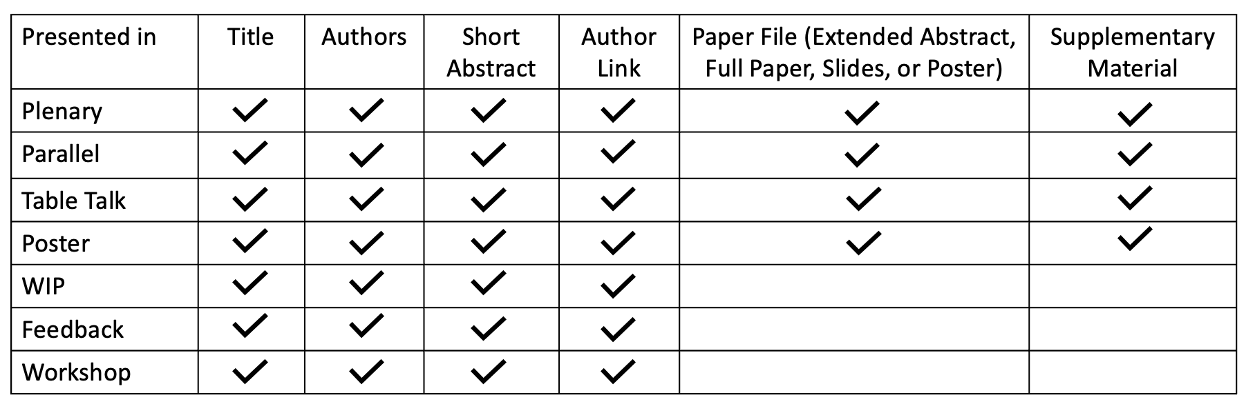
Figure 2: Content in Conference Proceedings by Presentation Type

Past Submissions by Thread

Table 1: Recent Distribution of Submissions by Thread
Thread | % 2023 | % 2022
Business & Strategy | 7.95% | 8.56%
Diversity | 1.89% | 5.81%
Economics | 3.79% | 6.12%
Environment & Resources | 22.73% | 18.65%
Health | 20.45% | 14.68%
Learning and Teaching | 7.20% | 4.59%
Methodology | 10.61% | 8.26%
Operations | 4.17% | 5.50%
Psychology & Human Behavior | 4.17% | 4.28%
Public Policy | 3.03% | 8.56%
Security, Stability & Resilience | 5.30% | 2.75%
Stakeholder Engagement | 3.79% | 5.50%
Transport & Mobility | 4.92% | 6.73%
Total | 100.00% | 100.00%

